SOCIAL MEDIA PLAN FOR “OF EBONY EMBERS” PERFORMANCES

Provided below are examples of potential social media posts for publicizing your upcoming scheduled Core Ensemble performance of “Of Ebony Embers”. We have included text, images, and links to further information for use on Facebook, Twitter, Instagram, LinkedIn, etc. Texts suitable for Twitter (144 characters or fewer) are indicated with *. Feel free to combine or edit these in the best way for your organization. Please consider tagging us in your posts (see below for where to find us) and we will share with our followers.

Website: http://www.coreensemble.com
Facebook: http://www.facebook.com/coreensemble
Twitter: http://www.twitter.com/coreensemble
LinkedIn: https://www.linkedin.com/company/the-core-ensemble
Merchandise: http://www.zazzle.com/thecorestore/clothing

IMAGE | TEXT | CHARACTERS
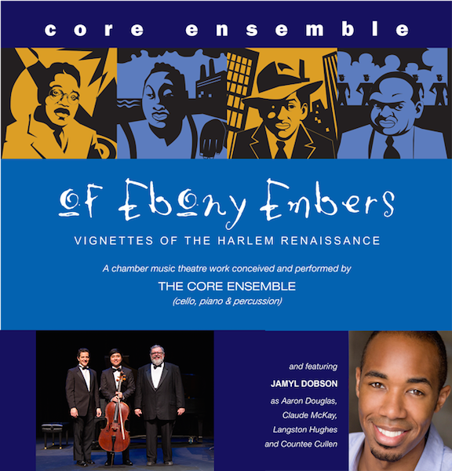 | “Of Ebony Embers – Vignettes of the Harlem Renaissance”. A chamber music theatre work conceived & performed by The Core Ensemble. | 129*
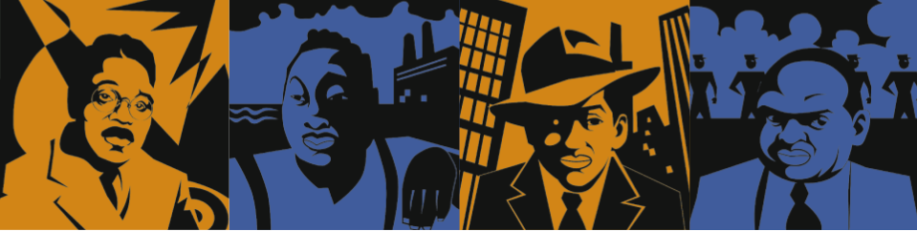 | “Of Ebony Embers” is a chamber music theatre work exploring the lives of African American artists who shaped the Harlem Renaissance. | 133*
 | The Harlem Renaissance was the cultural, social, & artistic explosion that took place in Harlem (NY) in the 1920s & 30s, drawing together black writers, artists, musicians, photographers, poets, & scholars. | 206
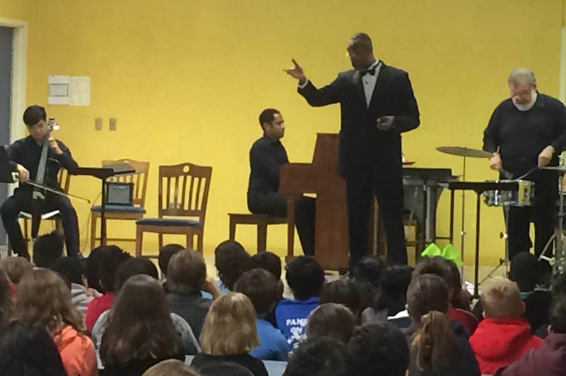 | Originated by The Core Ensemble, “Chamber music theatre” features a marriage of theatrical narrative to chamber music performance. | 130*
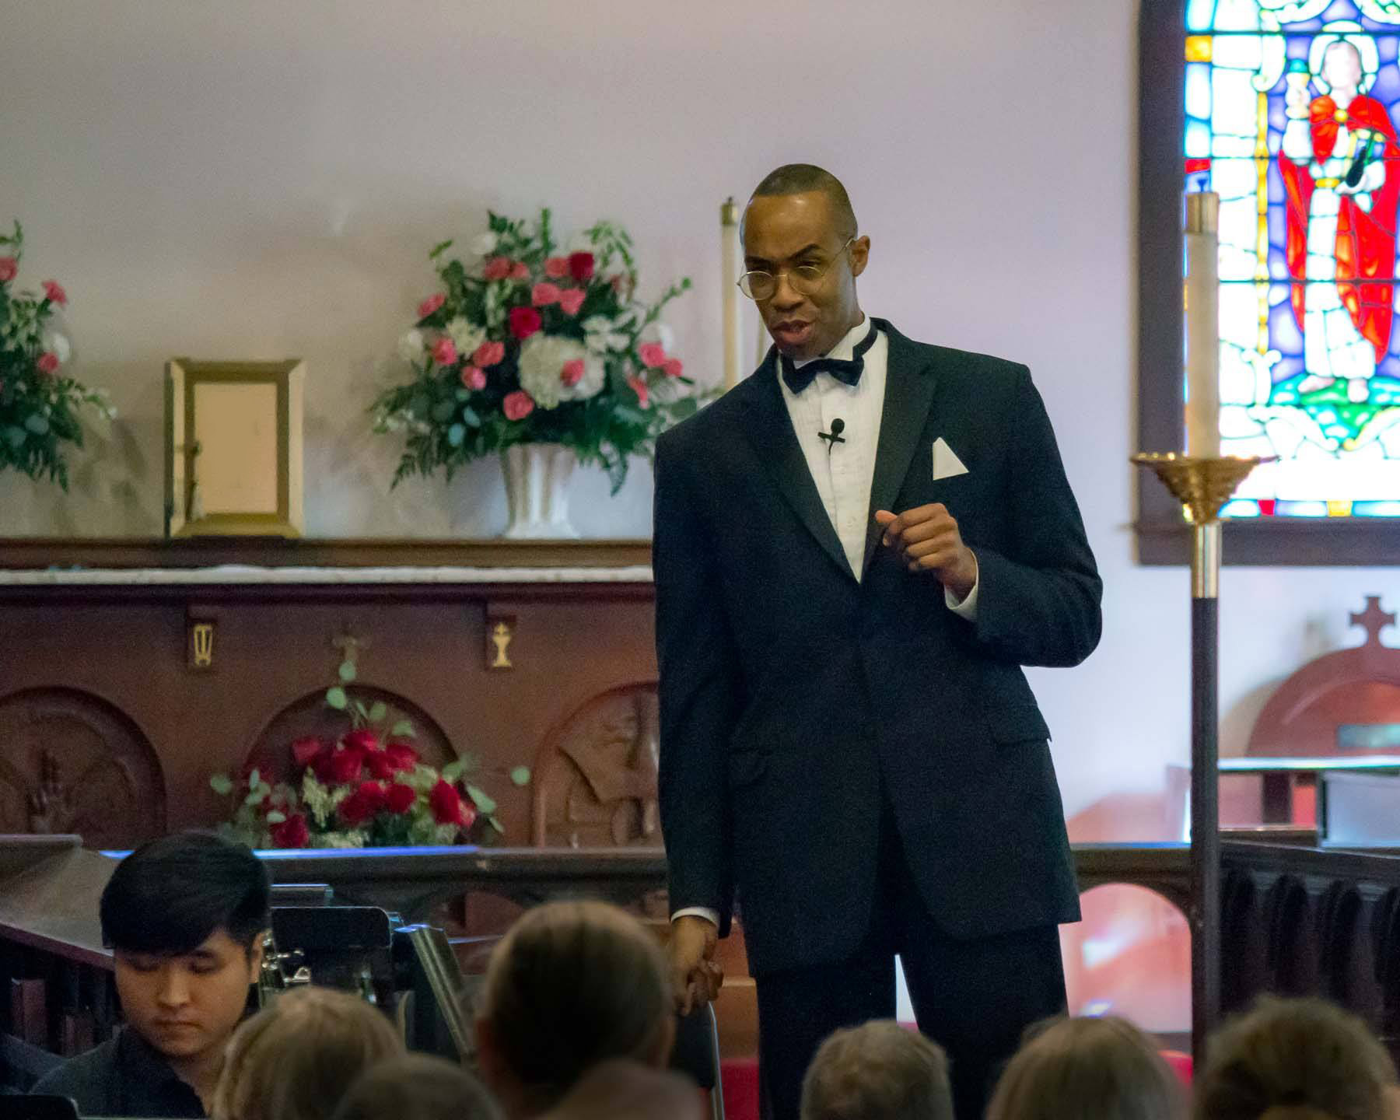 | Jamyl Dobson brings the Harlem Renaissance to life in “Of Ebony Embers”. Jamyl has performed at the Lincoln Center Festival, the Classical Theatre of Harlem, the La Jolla Playhouse, and the Pennsylvania Shakespeare Festival. A warm and engaging stage presence! (Photo shows Dobson portraying painter Aaron Douglas in Of Ebony Embers.) | 260
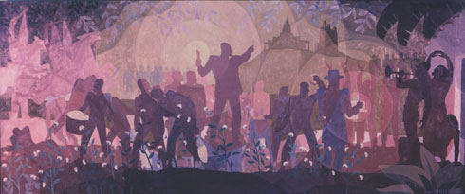 | Aaron Douglas (1899-1979) was an African-American painter & major figure in the Harlem Renaissance. His works include the mural “Aspects of Negro Life: From Slavery Through Reconstruction.” | 188
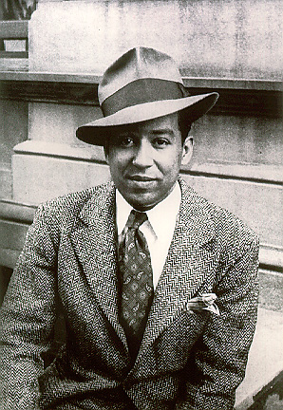 | Langston Hughes (1902-1967) was the author and editor of numerous works of poetry, fiction and history. His poem “To You” –  To sit and dream, to sit and read,  To sit and learn about the world  Outside our world of here and now-  Our problem world-  To dream of vast horizons of the soul  Through dreams made whole,  Unfettered, free-help me!  All of you who are dreamers, too,  Help me make our world anew.  I reach out my hands to you. | 429
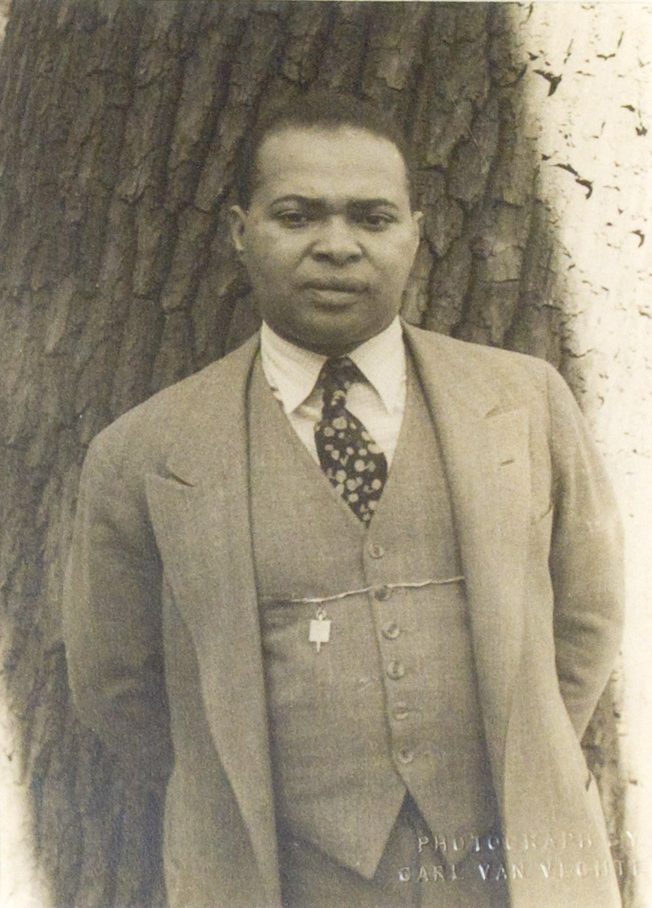 | Countee Cullen’s (1903-1946) poetry was published in national magazines such as Harper's, Century, and The Nation. His poem, “Yet Do I Marvel” -  I doubt not God is good, well-meaning, kind,  And did he stoop to quibble could tell why  Yet do I marvel at this curious thing:  To make a poet black, and bid him sing! | 312
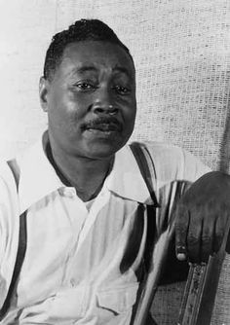  OR  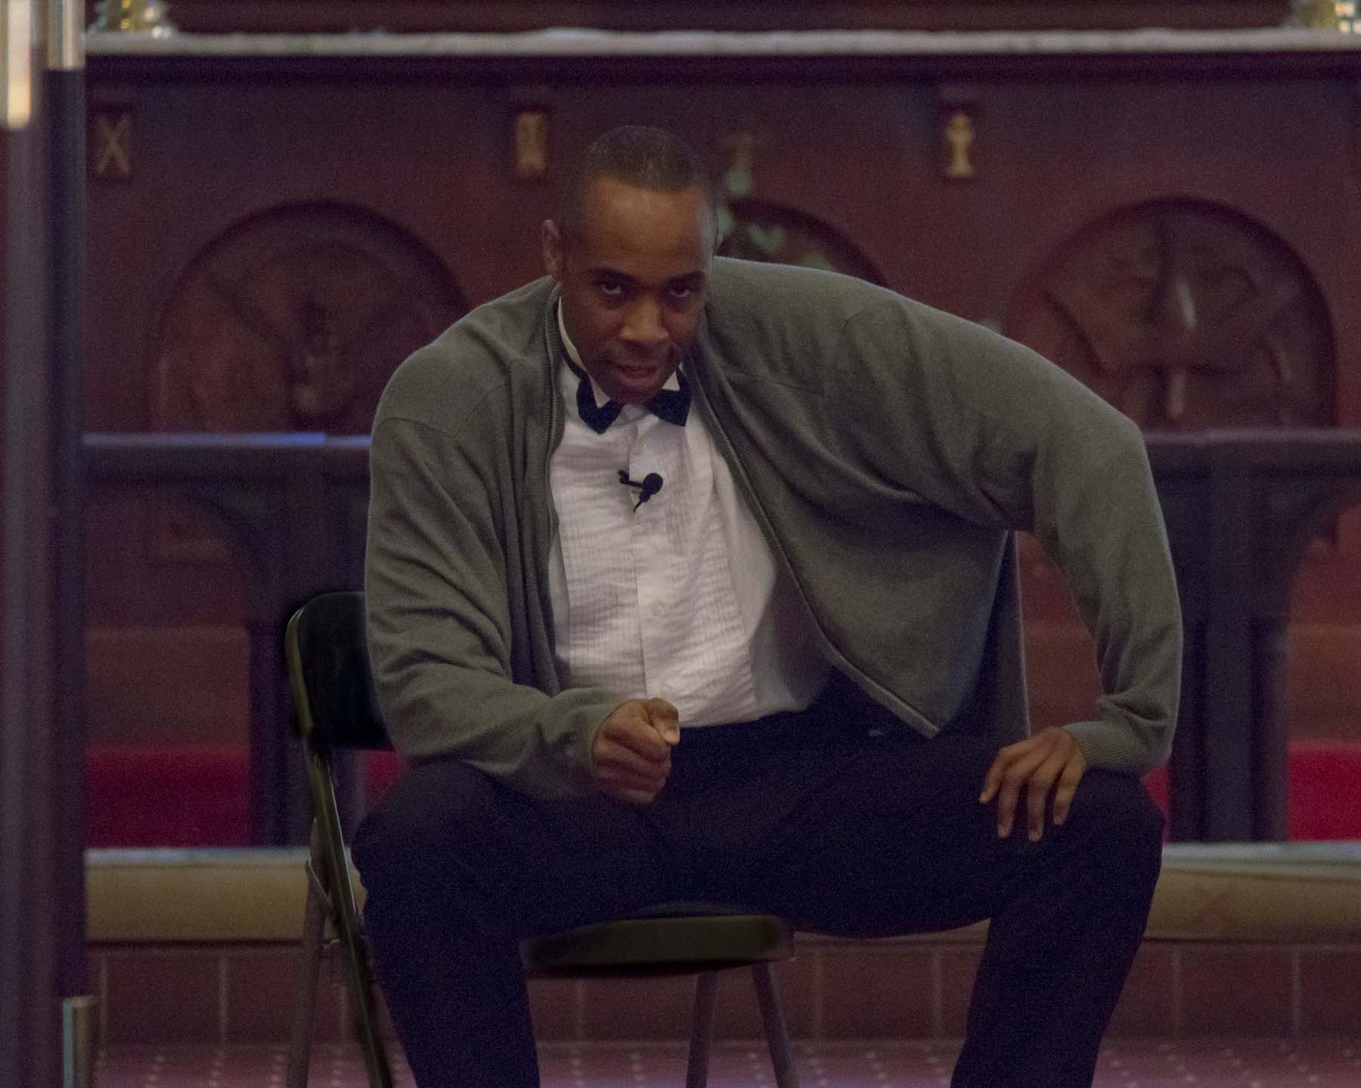  (Jamyl Dobson portraying poet Claude McKay in Of Ebony Embers) | Claude McKay’s (1889–1948) 1919 poem “If We Must Die” received wide attention on both sides of the Atlantic. It was read by Winston Churchill to a joint session of Congress as a plea for American intervention in World War II.  If we must die—let it not be like hogs  Hunted and penned in an inglorious spot,  While round us bark the mad and hungry dogs,  Making their mock at our accursed lot.  If we must die—oh, let us nobly die,  So that our precious blood may not be shed  In vain; then even the monsters we defy  Shall be constrained to honor us though dead!  Oh, Kinsmen! We must meet the common foe;  Though far outnumbered, let us show us brave,  And for their thousand blows deal one deathblow!  What though before us lies the open grave?  Like men we’ll face the murderous, cowardly pack,  Pressed to the wall, dying, but fighting back! | 820
 | The Core Ensemble celebrates Diversity and Multiculturalism in a marriage of theatre narrative and musical performance. These shows feature multicultural themes based on the accomplishments of real historical figures, and are a dynamic way of celebrating Diversity. | 265
 | The music of “Of Ebony Embers” includes works by jazz giants Duke Ellington, Jelly Roll Morton, Billy Strayhorn, Thelonius Monk & Charles Mingus as well as concert music by Jeffrey Mumford and George Walker. Watch a preview at bit.ly/ofebonyembers ! | 249
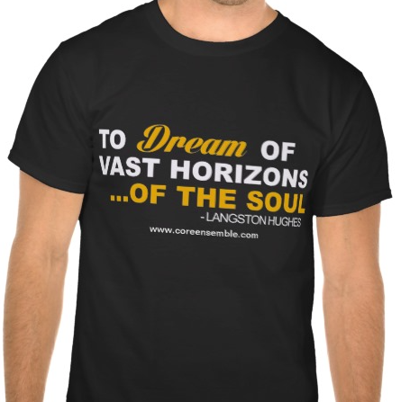 | You can buy t-shirts inspired by the Core Ensemble and “Of Ebony Embers” at  bit.ly/coretees | 91*

